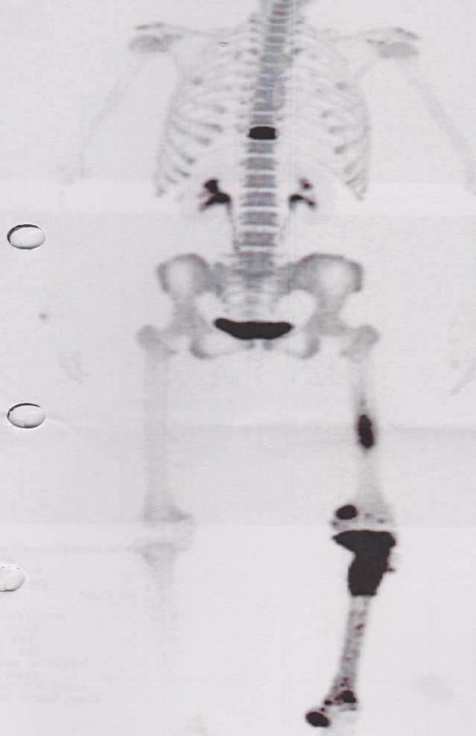

Fig-1Fig. 1 99Tc-MDP bone scintigram showing abnormal uptake in the left tibia

